**Assignment No.-2**

**Name of Student: KARPE VEDANT GORAKSHA**

**Batch: 3 Branch: IT Roll No 80**

**Problem Statement : Create a database with appropriate constraints using DDL and populate/modify it with the help of DML**

1. CREATE TABLE:

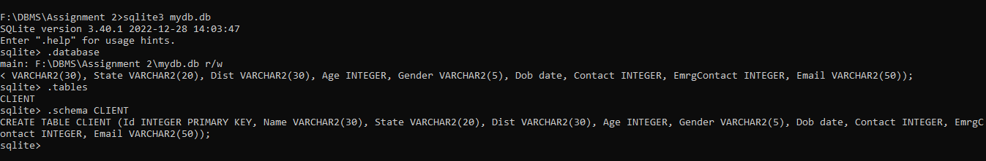

1. INSERT TABLE :



1. UPDATE TABLE :

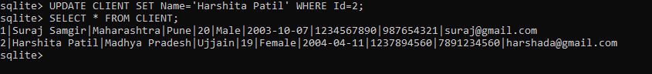

1. DELETE TABLE :

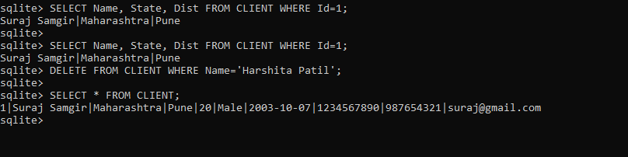

1. TRUNCATE TABLE :

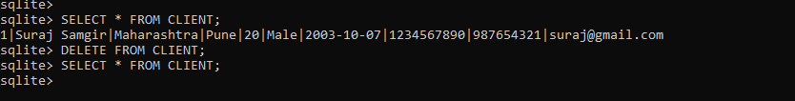

1. ALTER TABLE :

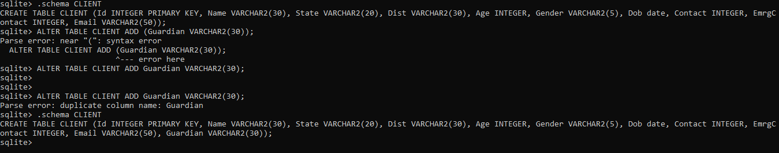

1. DROP TABLE :

